WEAU Plant Tours
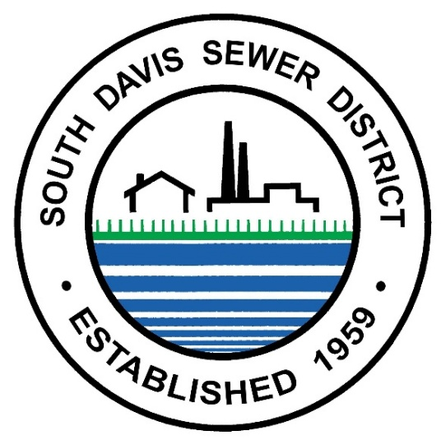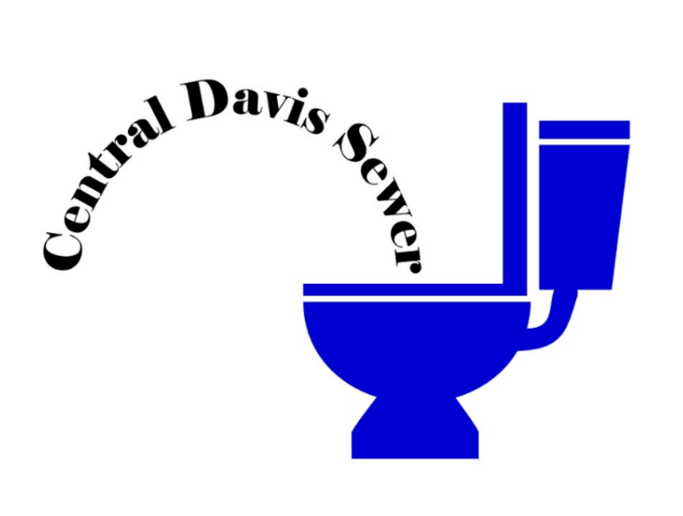
Date: August 26, 2026
Location 1: South Davis Sewer, South Plant
Time 1: 10:00 AM to 11:45 AM
Location 2: Central Davis Sewer
Time 2: 1:00 PM to 3:00 PM

Two Tours for the Price of One!
Registration is free but you must sign up through the WEAU website, participation will be capped at 50 people. This will be a great opportunity for new operators, state representatives and other WEAU members to get together, tour a plant, and network. Snacks and Drinks will be provided but participants are responsible for their own transportation and lunch.

South Davis Sewer, South Plant: 1380 W Center St, North Salt Lake
Central Davis Sewer: 2200 S Sunset Dr, Kaysville
Registration Deadline: Aug 24, 2026

